1. Index.html

1. Style.css

1. Backend

1. Index.js

Output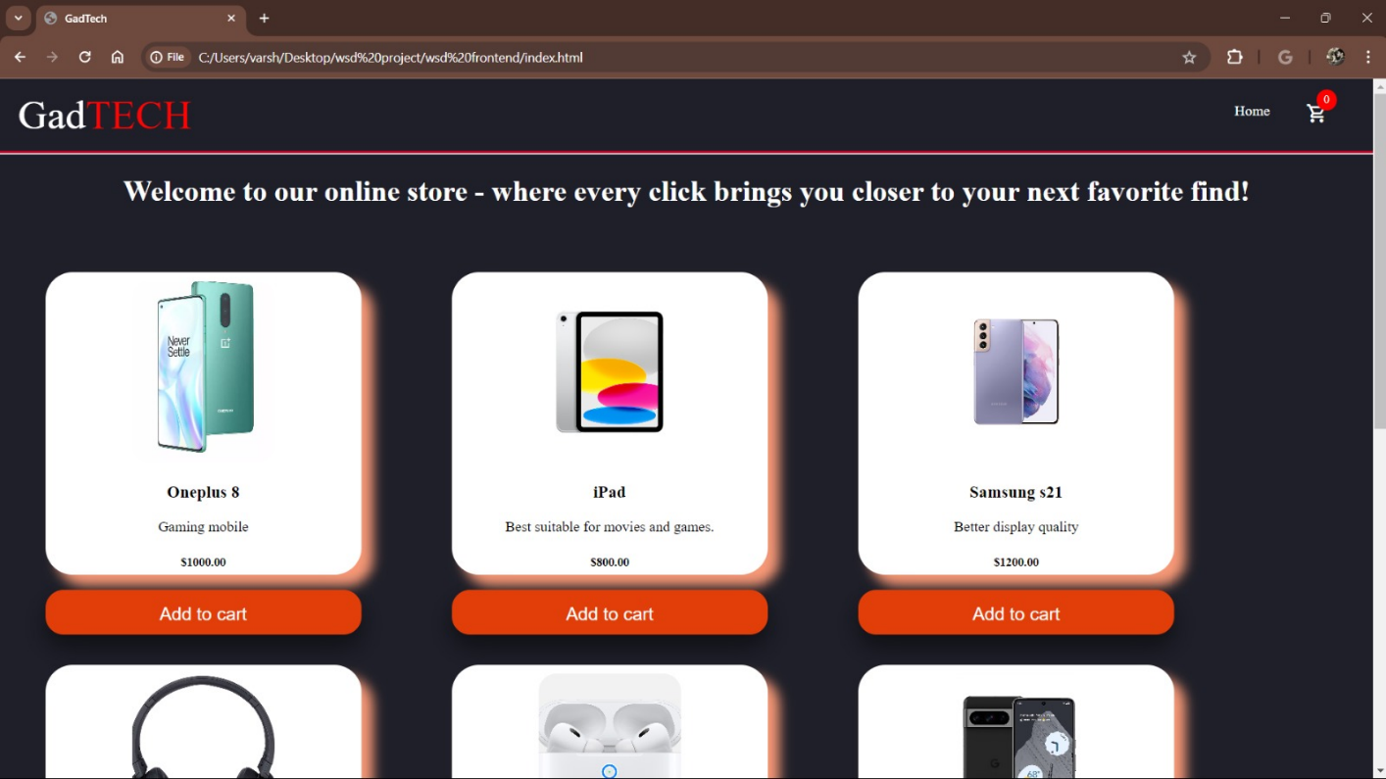

1. Cart.html

1. Cart.css

7.Cart.js

Output

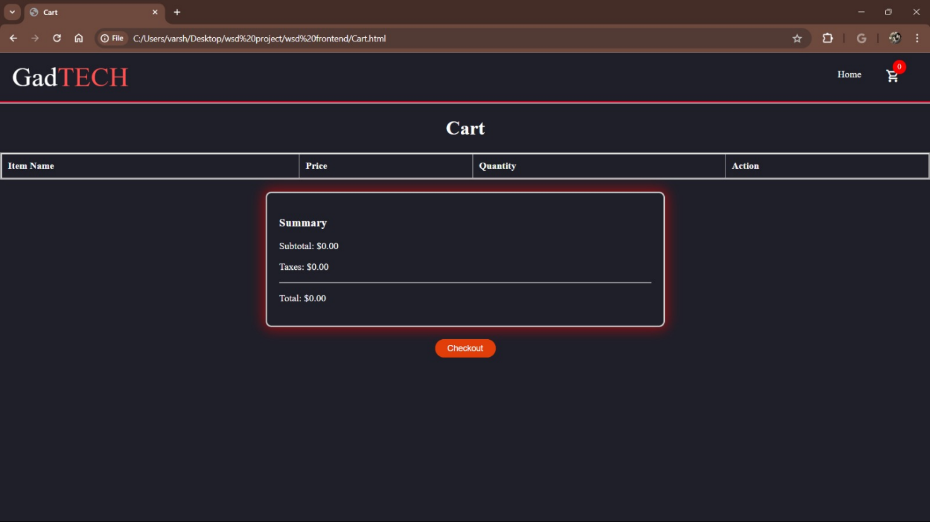

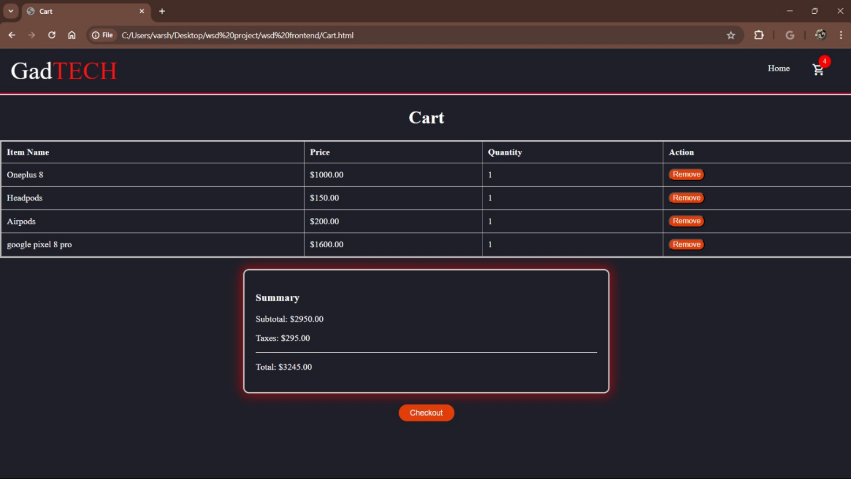

8.Payment.html

9.Payment.css

10. Payment.js

Output

